Ray Casting

* Single ray of line

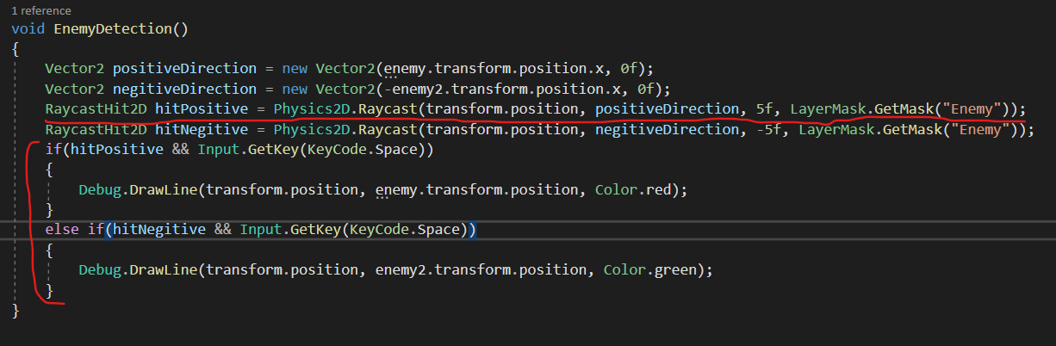

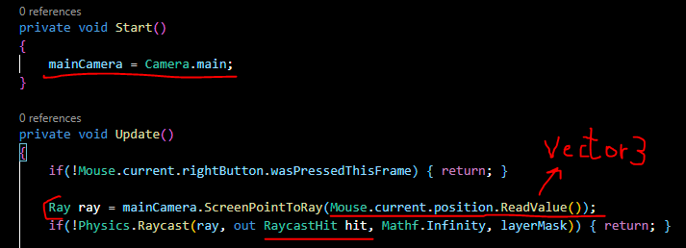

Note: ‘ Mouse.current.position.ReadValue() ‘ is inherited from new Input System.